Terraform-Final Task
Task Title
Terraform-Final Task
Objective
The objective of this task is to note the Terraform tasks posted on slack and worked on executing templates worked previously in 6 tasks.
Prerequisites
List all requirements before starting:
- AWS
- Visual studio code
- Terraform Modules
- Terraform Workspaces
IAC Infrastructure as co Code.
- Terraform is a tool to create ec2’s, VPC’s, Databases etc. without any manual intervention.
- Terraform is developed by HashiCorp.
- Terraform uses HCL Language (HashiCorp Language)
- Terraform official platform is – Terraform Registry

Alternative to Terraform?
Ans. CloudFormation in AWS

Difference between Terraform and CloudFormation in AWS?
- CloudFormation- It is used/restricted in AWS
- Terraform- It is used to provision on multiple cloud providers.

Different providers who provide Terraform on Cloud are:
- AWS
- Azzure
- Alibaba Cloud
- Google Cloud Provider (GCP)
- Kubernetes
- Oracle
The above are the providers who provides Terraform infrastructure.

Terraform provider:
It is a complete package of API calls to communicate with our resource.
- Any provider- AWS, Azzure etc.
- Resource- “local_file”

Visual Studio-
- Terraform init this is initializing Terraform
- Terraform plan Before executing the script, to verify, we can use plan
- Terraform apply Executing the script
- Terraform destroy to remove the file created
- Terraform fmt to organize our syntax automatically.

How terraform will understand everything?
- Through terraform.tfstate
- State file will have complete Terraform.

To get the formal or reference syntax of terraform navigate to website and check in registry
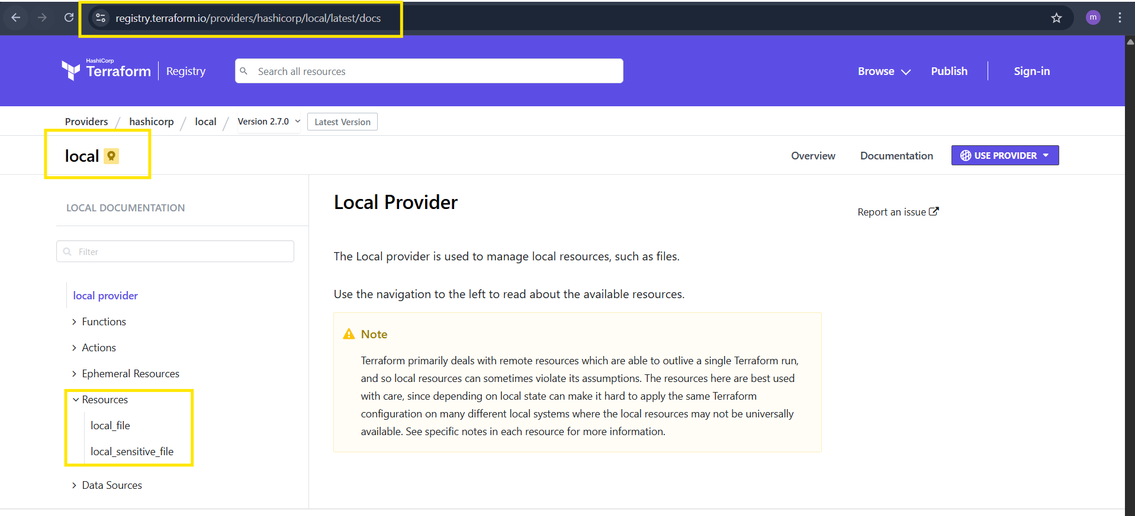
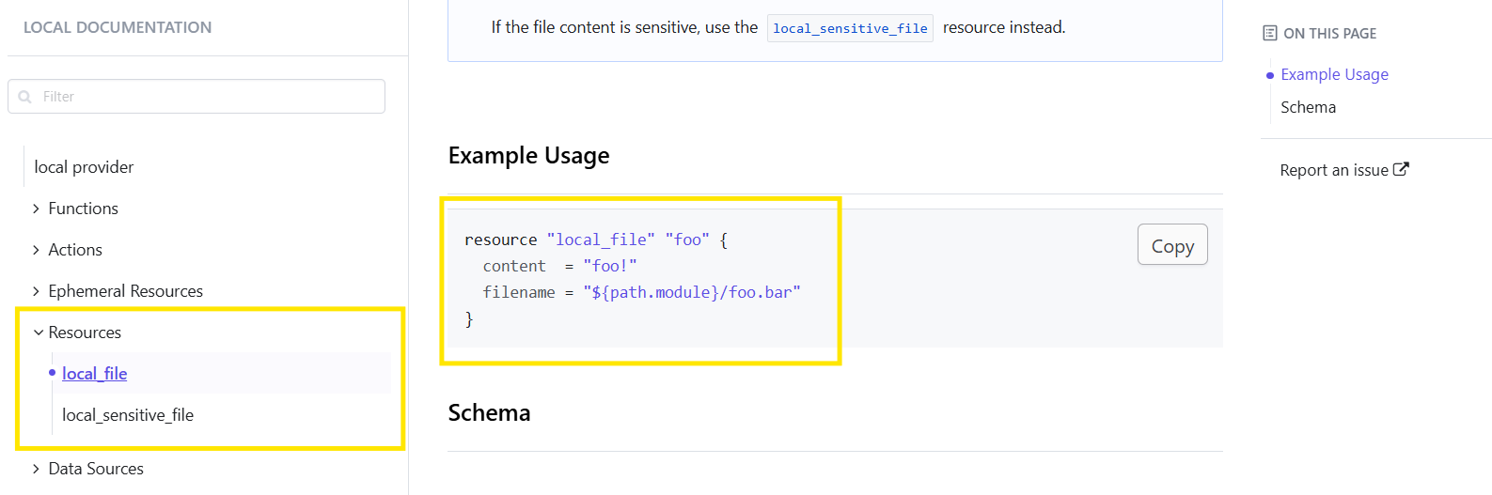
Providers of Terraform:
- Official – provided by Terraform
- Partner – provided by third party vendors
- Community – individual who can create

- Whenever we execute “terraform init” a .terraform will be created.
- Then, .terraform.lock.hel will be created as a Backup file.

Terraform.tfstate This will be created automatically when “Terraform apply” is executed.
- This is a blueprint and a metadata created by Terraform
- This will have the exact and complete information of our infrastructure
- This state file is our true source of data and by state file itself the execution is done.

Multiple ways to create a provider:
- Either, we can continue writing in the same directory and execute. Or else,
We can create a new directory main.tf use a new provider.
Configuration Directory:
- Main.tf – main configuration file containing resource
- Variables.tf – contains variable declaration
- Output.tf – contains outputs from resources
- Provier.tf – contains the provider definition

- Mainly, we will be using main.tf and variables.tf in Terraform.

- Terraform Immutable vs Mutable infrastructure:

Immutable: Immutable means deleted the one infrastructure and creating a new one.
Mutable: Mutable means using the same existing infrastructure and updating the system with newer version.

- Terraform uses Immutable infrastructure by destroying the previous version and creating a new one.
- Example, if there is a new version if nginx is available, then the previous version of server will be destroyed and new server will be launched.
- This is how Immutable infrastructure works.

Next Topic
Lifecycle Rules- Terraform

There are 3 lifecycle rules in Terraform
- Create_before_destroy
- Prevent_destroy
- Ignore_changes

Next Topic
Hard coded vs Soft coded

Hard coded:
What is hard coded?
Ans. It’s always not a best practice to make all the changes in main.tf file
Instead, we need to create a file – variables.tf and soft code and make all the changes in the variables.tf file, not on main.tf file.
That is the difference between Hard coded and Soft coded.

Types of Variables

- By using variables.tf
  - We can use soft coded instead of hard coded using variables.tf by creating a new file variables.tf and pass the content from main.tf to variables.tf
  - In main.tf, we have to update the filename and content to var.filename and var.content
  - In variables.tf, we have to update default= filename and type = matching variable.
  - Terraform apply and we can see 2 added and 2 destroyed.

- By using interactive mode (this will get activated if we don’t pass values in variable.tf)

- Once, we have varibales.tf file created and soft coded, we can use this type.
- Removed the contents in variable.tf and its empty now.
- If we have executed terraform apply, then, we will be asked to enter the content.
- This is interactive mode.

- Command line flags (terraform apply -var “filename=pets.txt” -var “content=I hate dogs” -var “prefix=MRS”)
- Instead of using interactive mode entering all content at each step, we can enter in 1 step using command- terraform apply -var “filename=pets.txt” -var “content=I hate dogs” -var “prefix=MRS”
- This is command line flags.

- Environmental Variable
- This is used when we are using some secrets like username/password, which we don’t want to expose to outside world
- Environmental variable are temporary, once we reboot/close the VS code, the content will be removed.
- There are two ways to use these environmental variables by commands:
  - Linux
  - Windows
- Linux- export TF_VAR_filename= “pets.txt”
- Windows- Set-Item -Path env:TF_VAR_filename -Value ‘pets.txt’

Here, we used Windows and executed terraform apply.

- variable definition file (Should be end with terraform.tfvars/terraform.tfvars.json)
--> for automatically loaded file name *.auto.tfvars/*.auto.tfvars.json
--> if we are saving the file with other name like varible.tfvars then we need to pass this in CLI
--> terraform apply -var-file terraform.tfvars
>>>No CLI flag needed — Terraform picks these up automatically.

- We just performed terraform apply and executed, where we didn’t automate.
- terraform apply -var-file terraform.tfvars
PRECEDENCE ORDER:
Order  1 | Option  Environment variables
2 | Terraform.tfvars
3  4 | *.auto.tfvars(alphabetical order)  -var or -var-file (Command line flags)

Terraform block: In some use case scenario, we need to use dedicated version, so that in future, even if we need to work on the same file, then, it will be helpful.
  - For that, we shall navigate Terraform registry
  - Search local
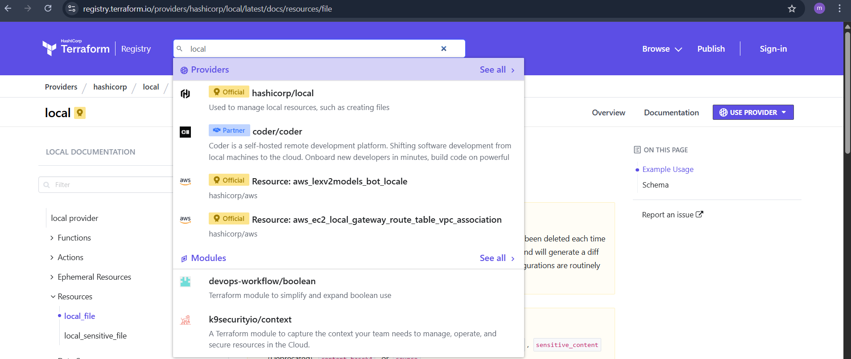
  - We can see below, there are multiple versions and we can choose any.
  - We can use previous versions as well to use dedicated one.
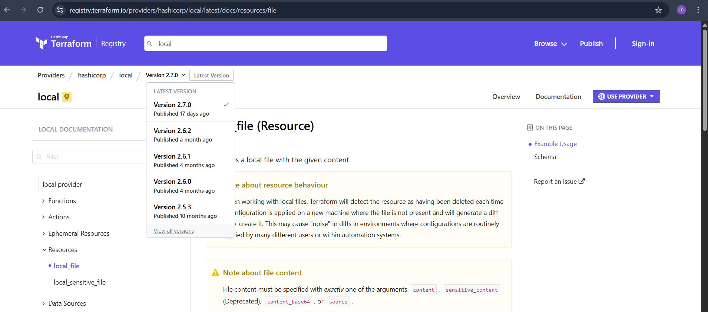
We can see in the right we have the dedicated version details, that should be passed on to the vs code for windows.

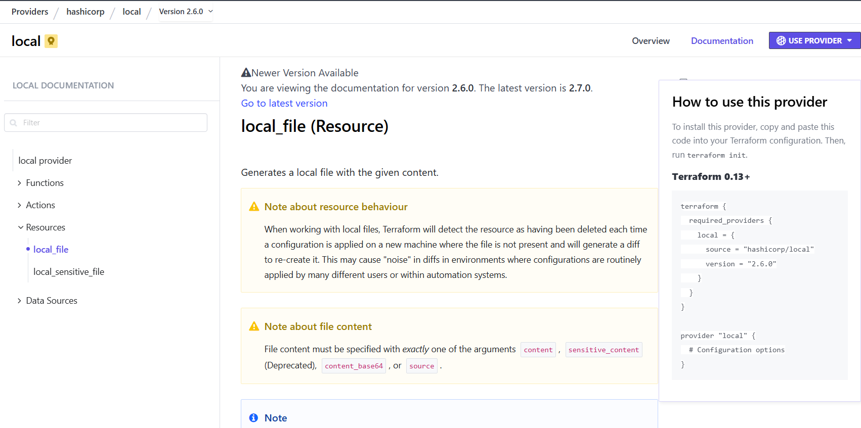
- We pasted the code to our windows vs code and shall execute “terraform init”

- Now, we shall how to use different commands to use versions.

Version = “2.3.0” --> download the exact version
Version = “!=2.3.0” -->will not use the mentioned version
Version = “< 2.3.0” -->lesses than the mentioned version
Version = “> 2.3.0” -->greater than the given version
Version = “~> 2.3.0” -->specific version or higher version.

Data Sources

Data block is to only read the content of the main infrastructure.
Using data source
We will call the content of the file using file name not by hardcoding the data in command line.

Meta-Arguments

Meta Arguments are used to create multiple resources and to change the behaviour of the resources.
Examples of meta-arguments:
  - Depends_on
  - Lifecycle rules
  - Count
  - For_each

Terraform Remote State and State Locking:

To store our Terraform configuration files and state file we can store in S3, terraform storage, harshicorp consul to store the state file.

State Locking:
State Locking is used to lock the statefile, so that no two users can execute the statefile the same point of time.

Remote Backend:
We will use S3 for remote backend.
State Locking:
We will use DynamoDB for State Locking.
===============================================================
To auto-approve:
Use command- --auto-approve
===============================================================

If we have used Terraform and why?
- We used Terraform to provision aws services by creating
  - VPC
  - Ec2
  - Route 53
  - CloudWatch Monitoring
  - S3
  - RDS

- We have used s3 as our backend and DynamoDB for state locking, so that we can push our tf.statefile to s3 without manual intervention
- Used DynamoDB, so that, no multiple users can execute at the same point of time.

Terraform Provisioners

- We have two provisioners
  - Remote Provisioners
  - Local Provisioners

Terraform Modules:
What is Terraform Modules- Terraform modules is a collection of configuration files in a directory.
For example: If we want to create two ec2 instances in 2 different environments, then we can create a directory for aws_instance configuration.

We shall see the process below how to create a directory for aws_instance and call from different environments.
My main workspace- aws_instance

Workspaces

Terraform Workspaces
This is similar to Terraform modules, there is a simple difference between them, where we do not require to create separate directories (environments). Instead, we can create them in aws_instance directory itself through Workspace.

Terraform Final Task

- Create VPC

Step by step Implementation:

Syntax:
resource "aws_vpc" "terraform_vpc" {
cidr_block = "10.0.0.0/16"

tags = {
Name = "terraform-vpc"
}
}

Terraform init
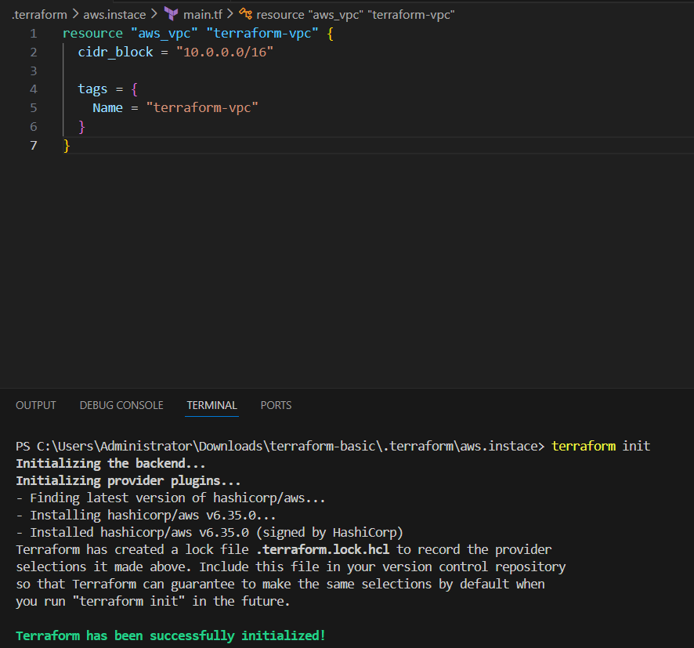

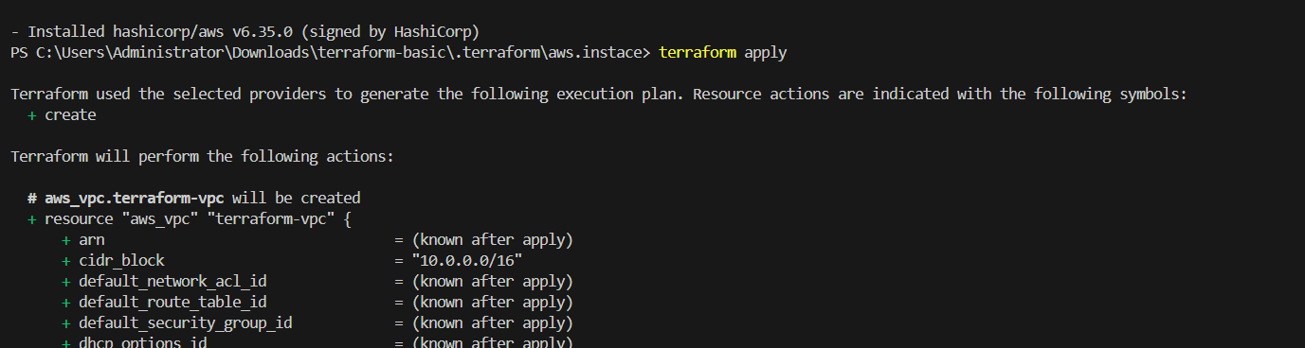
VPC resource has been successfully created
Verified in aws
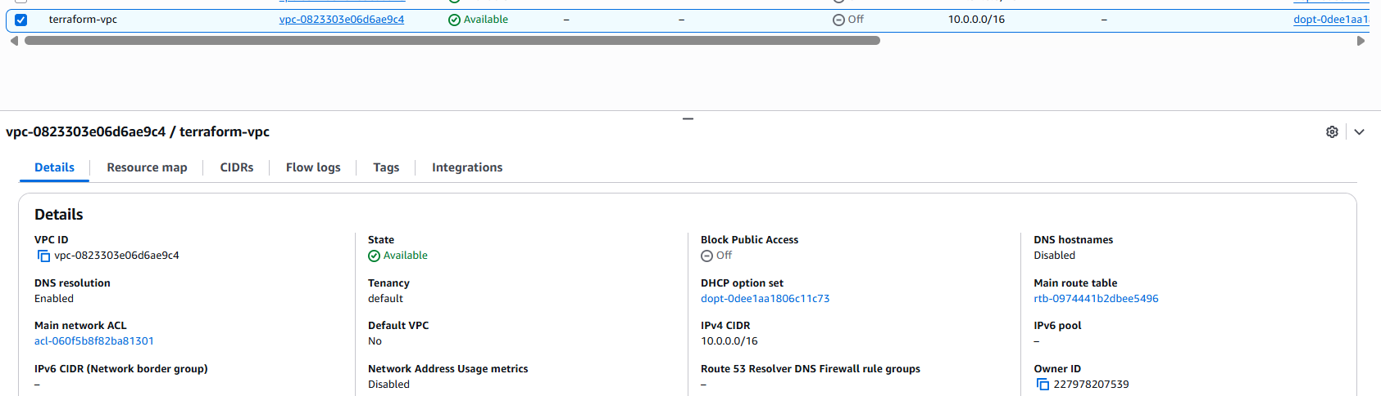

2.Create Internet gateway
Syntax:
resource "aws_internet_gateway" "terraform_igw" {
vpc_id = aws_vpc.terraform_vpc.id

tags = {
Name = "terraform-igw"
}
}
Terraform init
Terraform apply

And now terraform apply

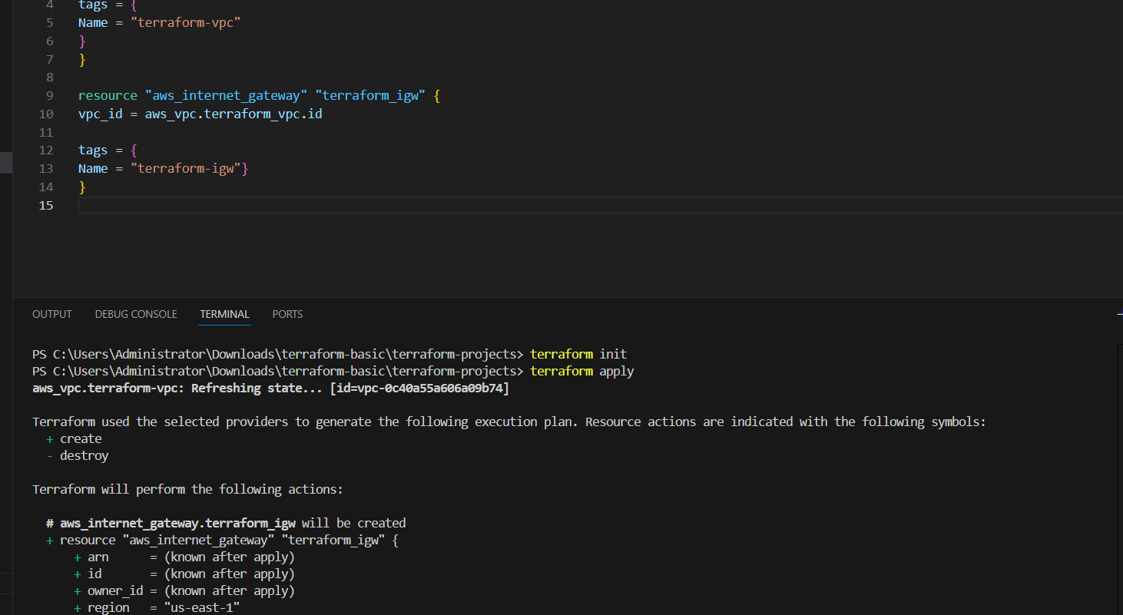
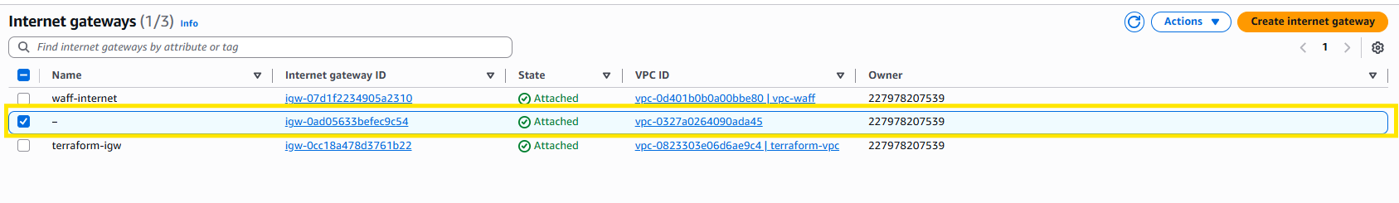
3. Create Custom Route Table

Syntax
resource "aws_route_table" "terraform_rt" {
vpc_id = aws_vpc.terraform_vpc.id

tags = {
Name = "terraform-rt"
}
}
Terraform init
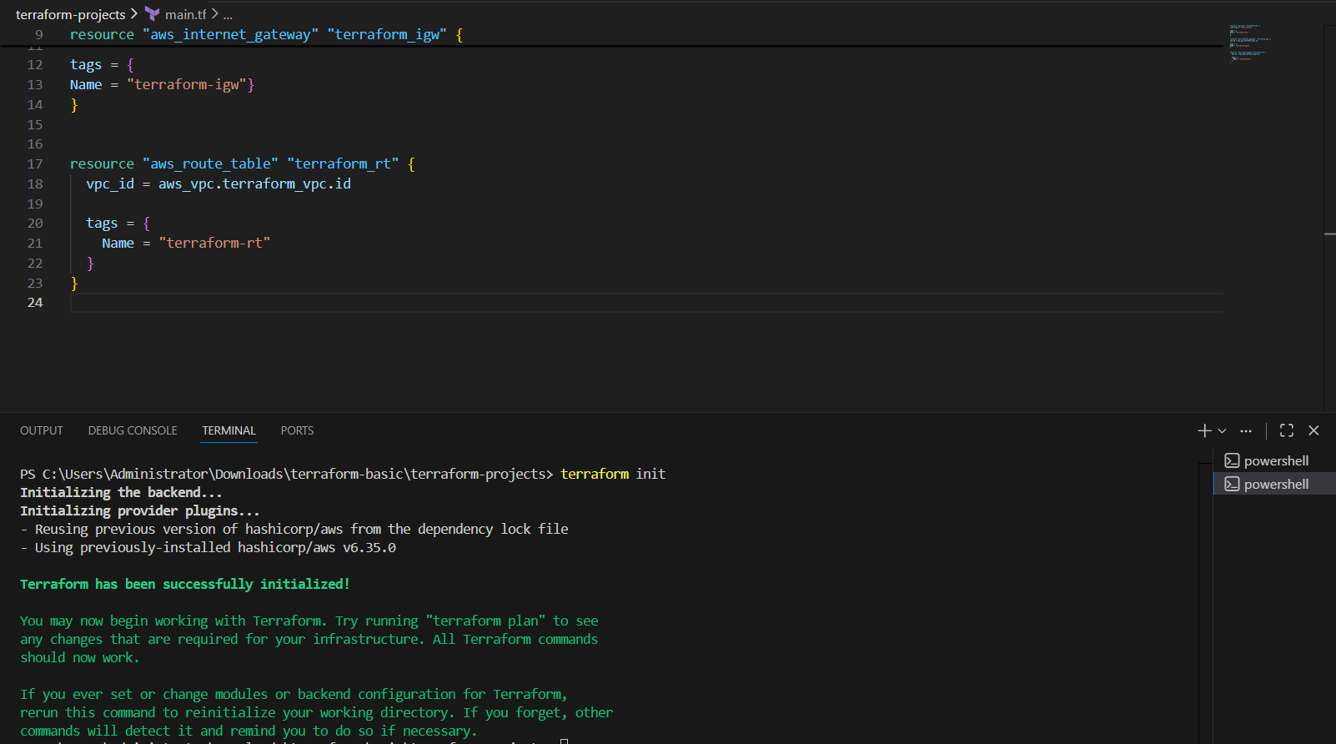
Now terraform apply
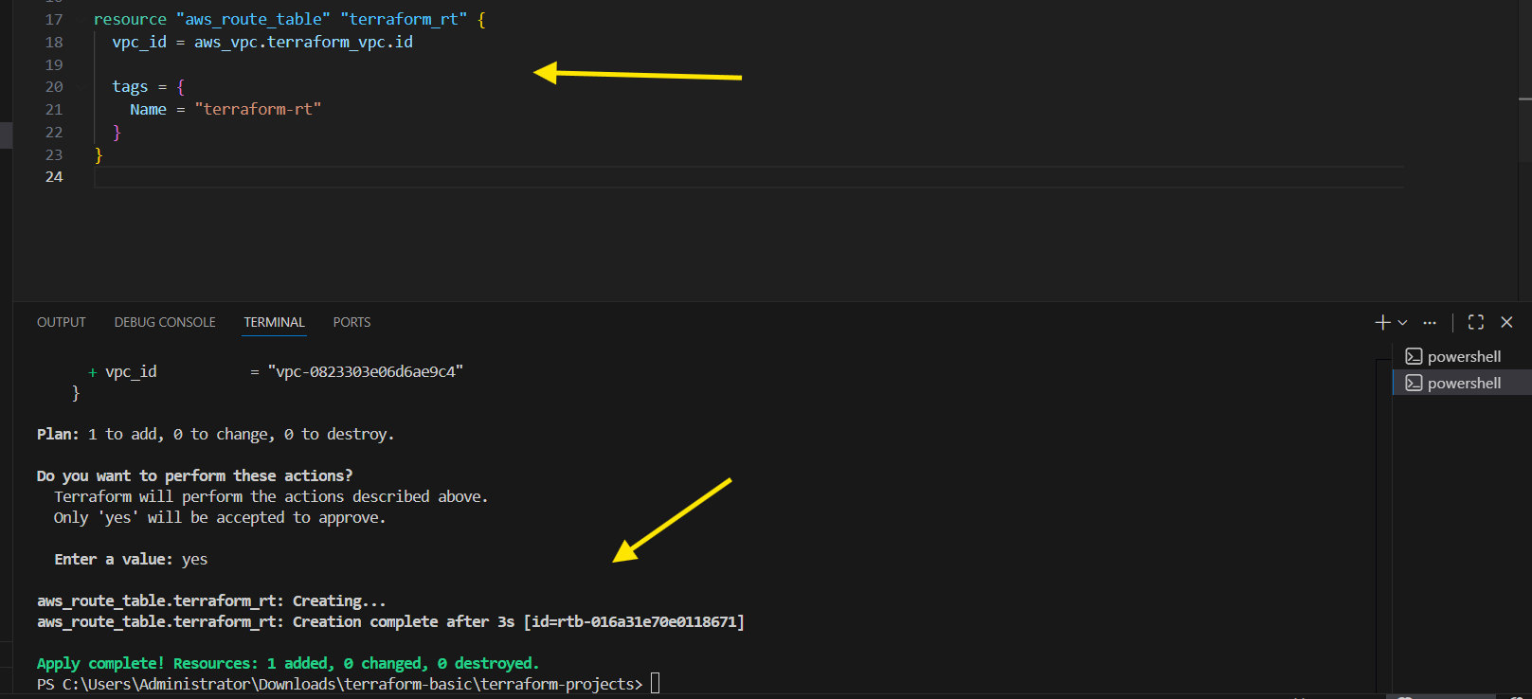
Now lets verfy it on aws
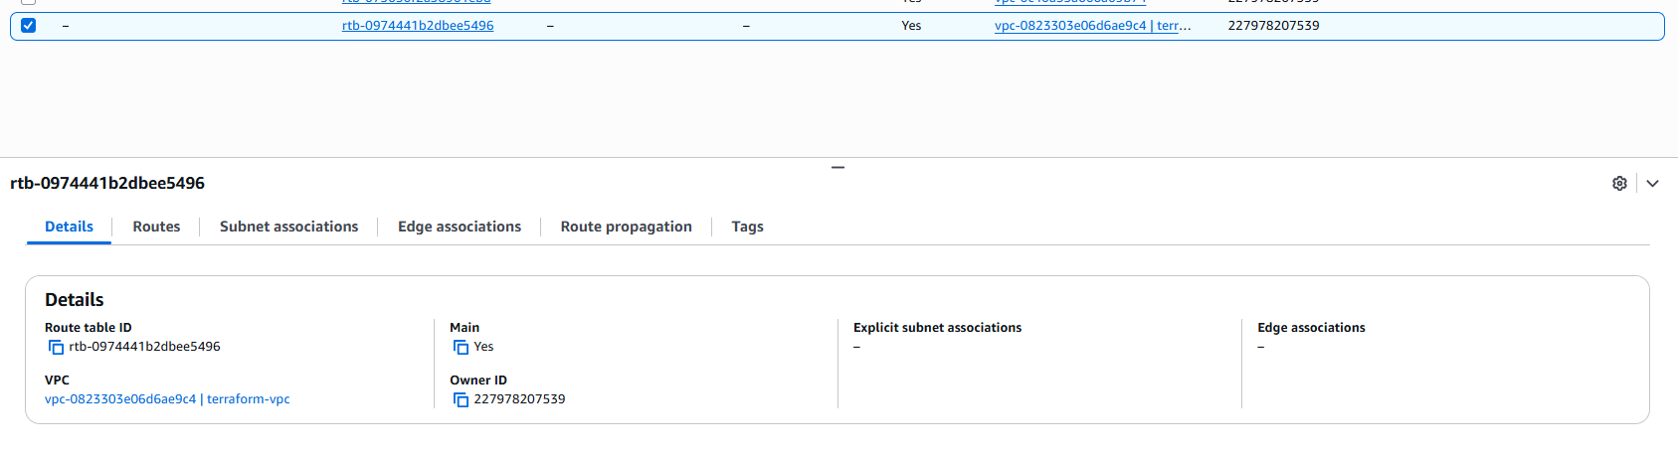
Route table has been modified with adding internet gateway.
4. Create Subnet
Syntax
resource "aws_subnet" "terraform_subnet" {
vpc_id = aws_vpc.terraform_vpc.id
cidr_block = "10.0.2.0/24"
availability_zone = "ap-south-1a"

tags = {
Name = "terraform-subnet"
}
}

}
}
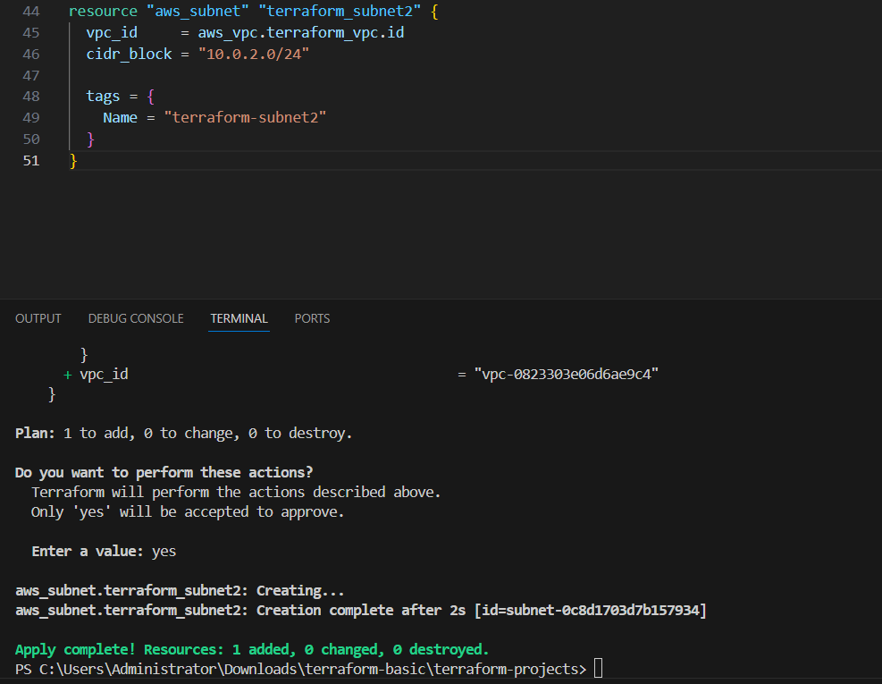

5. Associate subnet with Route Table
Syntax

resource "aws_route_table_association" "terraform_rta" {
subnet_id = aws_subnet.terraform_subnet.id
route_table_id = aws_route_table.terraform_rt.id
}
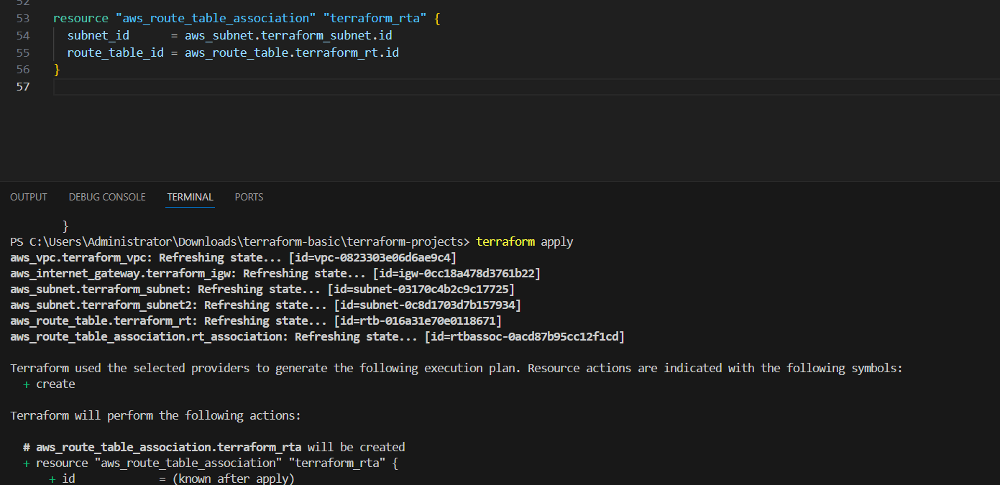
Now lets verfy it
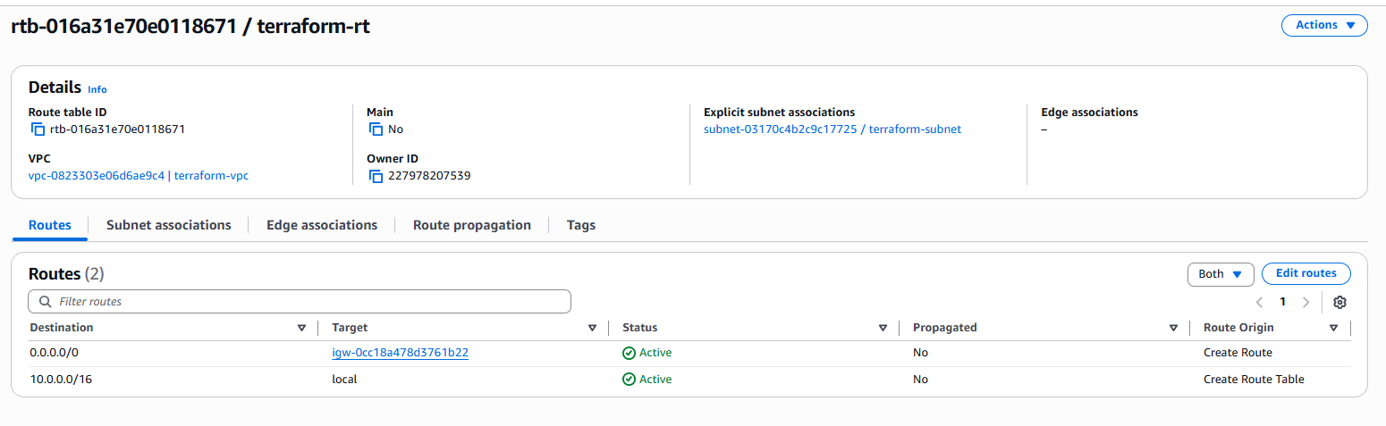
6. Create Security Group to allow port 22.80,443
Syntax

resource "aws_security_group" "terraform_sg" {
vpc_id = aws_vpc.terraform_vpc.id
description = "Allow all inbound traffic"
ingress {
from_port = 22
to_port = 22
protocol = "tcp"
cidr_blocks = ["0.0.0.0/0"]
}
ingress {
from_port = 80
to_port = 80
protocol = "tcp"
cidr_blocks = ["0.0.0.0/0"]

}
ingress {
from_port = 443
to_port = 443
protocol = "tcp"
cidr_blocks = ["0.0.0.0/0"]
}
egress {
from_port = 0
to_port = 0
protocol = "-1"
cidr_blocks = ["0.0.0.0/0"]
}

tags = {
Name = "terraform-sg"
}
}
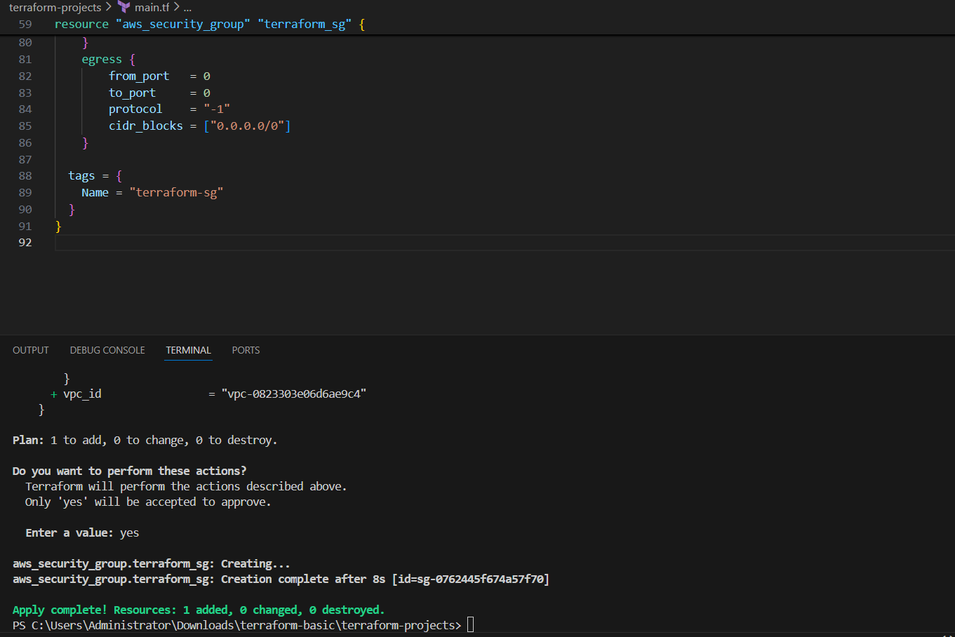
Verfy it
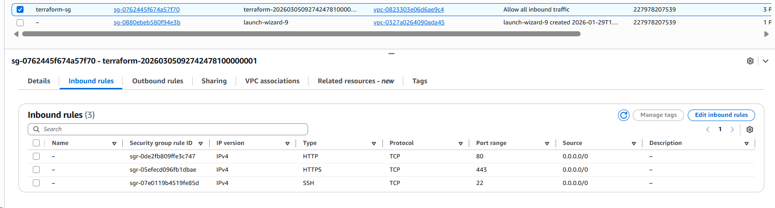
7. Create a network interface with an ip in the subnet that was created in step 4

Syntax
resource "aws_network_interface" "terraform_eni" {
subnet_id = aws_subnet.terraform_subnet.id
security_groups = [aws_security_group.terraform_sg.id]

tags = {
Name = "terraform-eni"
}
}
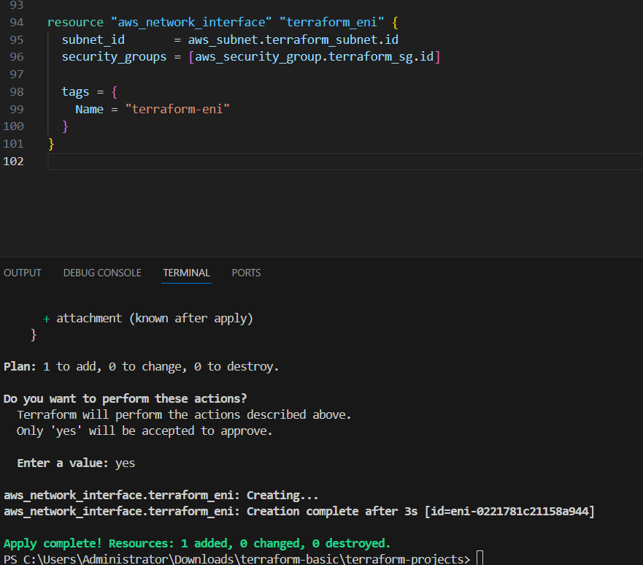
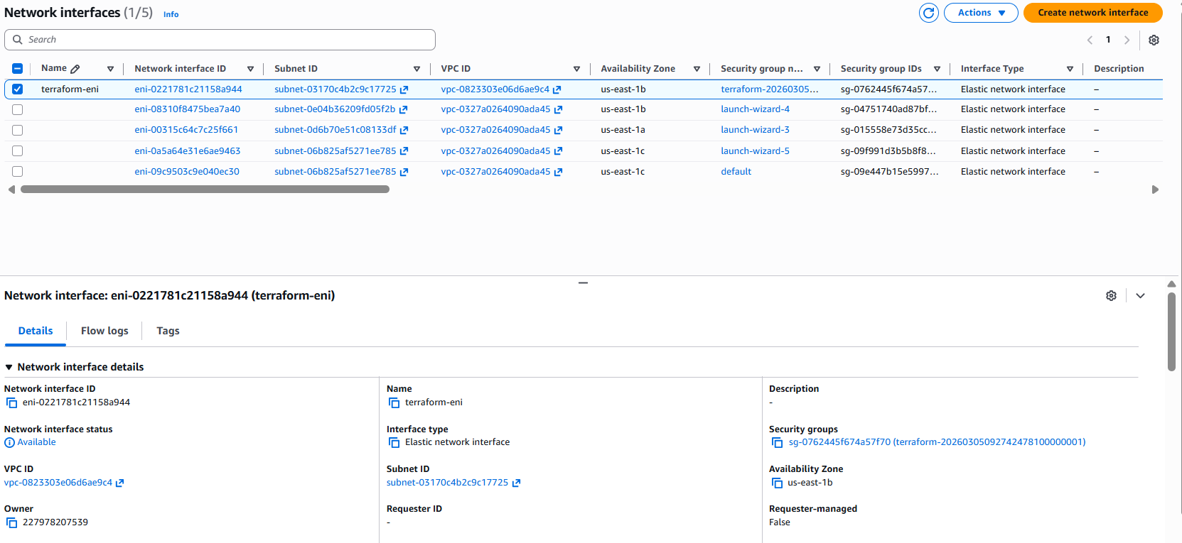

8. Assign an elastic IP to the network interface created in step 7

Syntax

resource "aws_eip" "terraform_eip" {
domain = "vpc"
network_interface = aws_network_interface.terraform_eni.id
tags = {
Name = "terraform-eip"
}
}
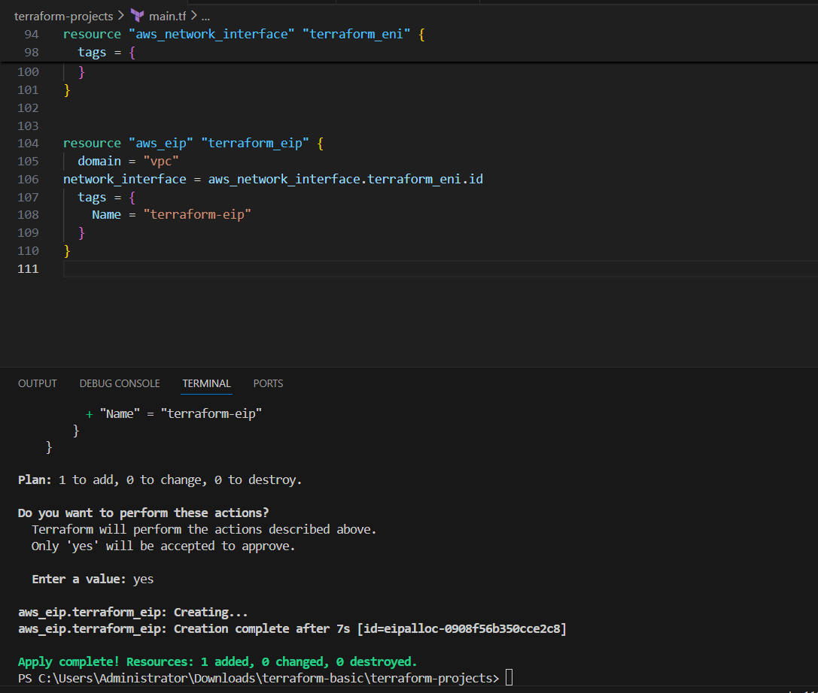
Now lets verfy it
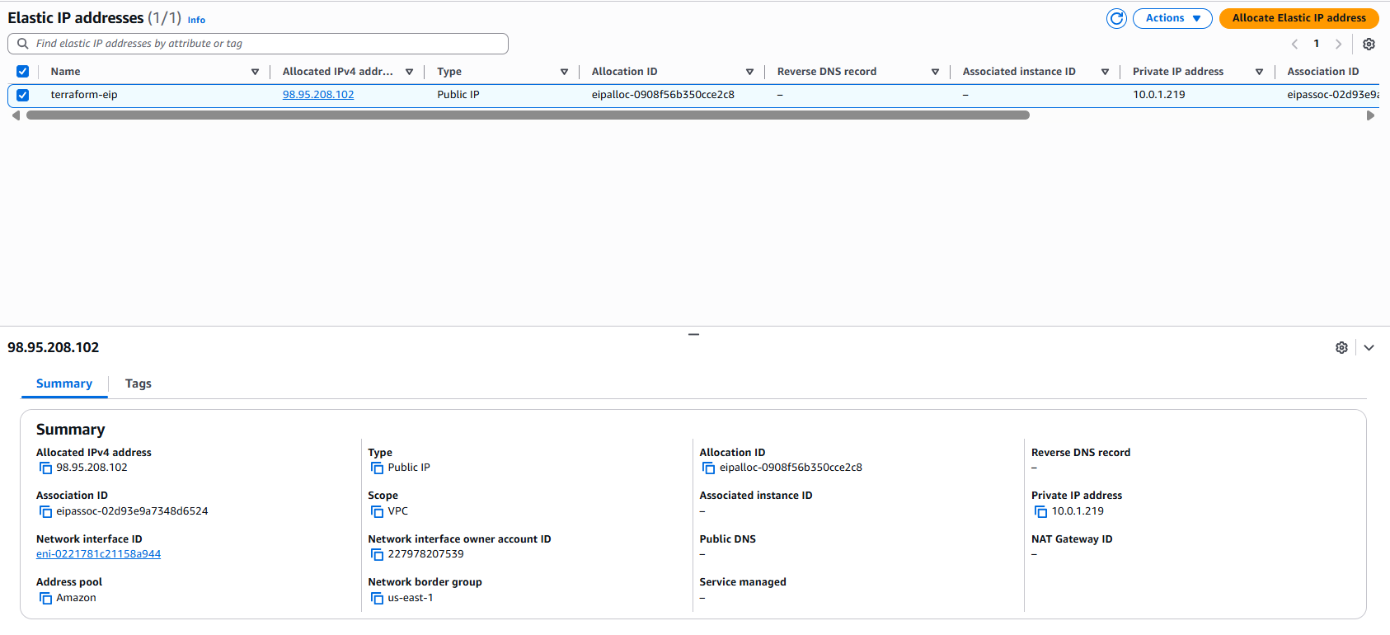

9. Create Ubuntu server and install/enable apache2

Syntax

resource "aws_instance" "terraform_instance" {
ami = "ami-0b6c6ebed2801a5cb"
instance_type = "t3.micro"
network_interface {
network_interface_id = aws_network_interface.terraform_eni.id
device_index = 0
}
tags = {
Name = "terraform-instance"
}
user_data = <<-EOF
#!/bin/bash
apt update -y
apt install -y apache2
systemctl start apache2
systemctl enable apache2
EOF
}
output "network_interface_id" {
value = aws_network_interface.terraform_eni.id
}
output "instance_public_ip" {
value = aws_eip.terraform_eip.public_ip
}
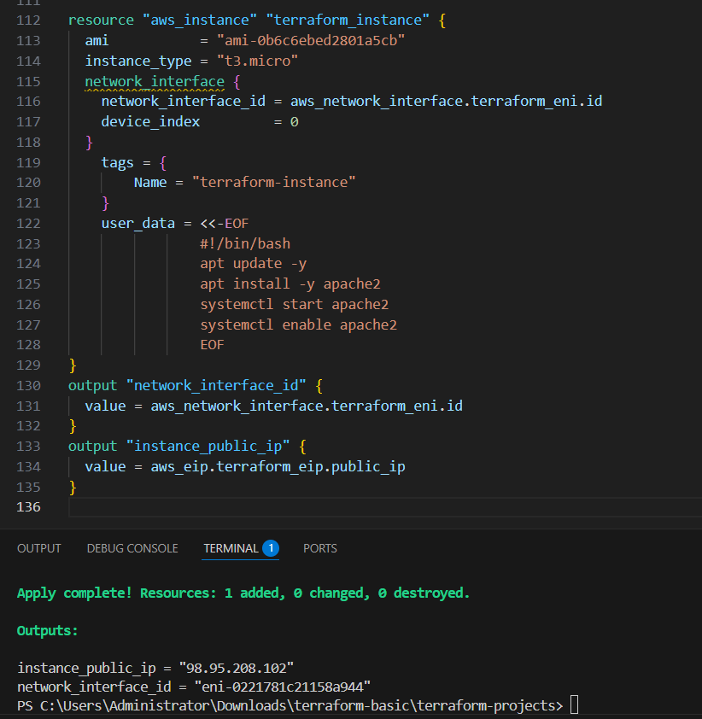
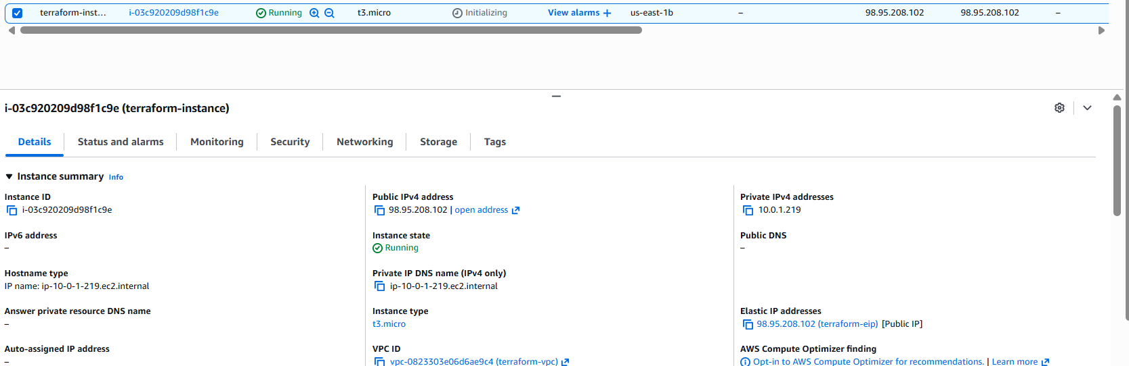
Now lets verfy it
